La ferme écologique :

Une ferme écologique qui est aussi une maison d'hébergement
Madame Rachel Jetté
Coordonnatrice
Monsieur Éric Schattauer
Animateur
Madame Johanne Laforest
Animatrice
Ferme écologique D-Trois Pierres
La ferme écologique du Cap-Saint-Jacques exploite un jardin écologique, un poulailler, une érablière, 81 des ruches. Des jeunes en difficulté y résident de 6 mois à un an, le temps de se “ dépolluer ” et de reprendre goût au travail et à des habitudes de vie plus saines. D-Trois Pierres est à la fois une expérience écologique et communautaire (“ un climat familial ”, dit Rachel Jetté). La ferme est située dans le parc régional du Cap Saint-Jacques à l'extrême Ouest de l'île de Montréal et les visiteurs du parc y sont les bienvenus.
Les besoins fondamentaux des personnes
L'approche de D-Trois Pierres consiste à travailler sur les “ besoins fondamentaux ” des personnes, et ceci dans le cadre d'une utilisation respectueuse des ressources disponibles sur place, faire plus avec moins, en quelque sorte. Par exemple, le “ besoin de se nourrir ” a induit l'utilisation d'une partie du terrain pour en faire un jardin “ écologique ”, tandis qu'un vieux bâtiment était recyclé en poulailler et qu'on mettait sur pied un atelier de cuisine.
Autre aspect de la valorisation des besoins essentiels : par son séjour à D-Trois Pierres, on veut permettre au jeune de “ se dépolluer ”, de retrouver des habitudes et des rythmes plus sains que favorise la nature omniprésente. Le rythme de la vie y est “ plus naturel, anti-stress ” : les 15 à18 jeunes (18-30 ans) qui y résident avec le couple d'intervenants (et leur enfant !) travaillent de 4 à 5 heures par jour et, Rachel Jetté insiste, ils ont le choix des tâches. Au delà de la responsabilisation devant des gestes constructifs librement consentis, le jeune peut identifier ses aptitudes et préférences, améliorer sa confiance et ultimement s'orienter à plus long terme dans l'existence.
Un dernier volet concerne l'accueil des familles qui visitent le parc et s'arrêtent à la ferme. Le fait d'aller chercher les produits “ à la source ”, comme de cueillir les oeufs ou d'explorer le jardin, a une valeur éducative certaine chez les plus jeunes. Par ailleurs, D-Trois Pierres appuie sans réserve les objectifs de la CUM (Communauté urbaine de Montréal) concernant l'animation des parcs régionaux. Car, dit Rachel Jetté, “ leur but ultime est de préserver la valeur écologique des sites pour des fins éducatives, de conservation et de récréation ”.

Le respect de la terre et le recyclage
“ Le respect de la terre, des animaux et des humains : c'est ce que ça nous apprend que de vivre là ”, conclut Rachel Jetté. Éric Schattauer, animateur à D-Trois Pierres, abonde dans le même sens: “ avec le travail sur la ferme, on devient beaucoup plus conscient; en le vivant comme ça au quotidien, on l'approfondit ”. Mais “ avoir des opinions claires et nettes, ça a [aussi] ses inconvénients ”, d'avancer la coordonnatrice. Ainsi, des skieurs qui s'étaient arrêtés au casse-croûte tenu pendant l'hiver leur ont fait valoir que les verres de styrofoam, “ ce n'est pas très écologique ”.. Or, la vraie vaisselle, il faut bien que quelqu'un la lave, et ce ne seront pas les clients qui vont le faire... Autre exemple : ils aimeraient bien trouver à vendre plus facilement leurs produits, mais les visiteurs les encouragent à conserver le climat actuel, “ un climat familial, un climat très humain... mais pas très productif ! ”
En effet, à D-Trois Pierres, on a réussi à recycler en tuteurs pour le jardin des clôtures à volailles qui avaient été jetées, on y fait du compostage, et ainsi de suite. Mais pourront-ils aller jusqu'à se passer d'un tracteur tel que monsieur Schattauer en exprime le voeu ? Ne dit-il pas lui-même : “ on est membre d'une société qui met une pression à la consommation. On est submerges par la quantité de gadgets, par les emballages; on a beau essayer de recycler, on ne peut réutiliser tout ça ”. Et d'ajouter : “ la famille en tant que consommateur contribue au problème, mais elle est aussi victime ”. Nous serions tentés de préciser : victime dans la mesure ou les choix qui orientent la production marchande lui échappent presque totalement; de là vient la nécessité pour plusieurs, de s'organiser pour créer un pouvoir compensateur.
Le parc régional est situé au 21 262, boulevard Gouin Ouest (extrême-ouest de l'Île) et on trouve la ferme au 205, chemin du Cap Saint-Jacques. Attention : l'endroit a beau être agréable (jusqu'à 2000 visiteurs par jour l'été passé), il n'est ouvert aux familles que la fin de semaine.

MODEL FARM FOR A NATURE RESERVE IN THE AMAZON FOREST

Country and Area of Intervention
The Xixuau-Xiparina Nature Reserve, Rio Jauaperi, Brazilian Amazonia

Project Description
The Associacao Amazonia and the Associazione Amazonia Onlus have been running the Xixuau-Xiparina Nature Reserve on the Rio Jauaperi which divides the Amazonian States of Roraima and Amazonas since the beginning of 1992. The reserve measures 172,460 hectares and was demarcated in 1996
A recent agreement with IBAMA foresees the enlarging of the reserve to approximately three times its current size.
The reserve guarantees environmental protection for the area and in it a number of projects are taking place for improving the lives of the local inhabitants, for the sustainable development of the communities along the Rio Jauaperi and scientific research is being carried out by Universities and Institutes from several countries.
The Association provides a health service and schooling for the local children.
Financial aid from the Kleinwort Trust has contributed to improving the living conditions of the people of the area and recently led to the installation of solar energy and a satellite internet link up in the reserve. Computers have been installed and the children of the reserve are receiving computer courses and further education on-line.
Malaria has been brought under control in the region and the Association employs a full time Brazilian nurse to run the health project.
A telemedicine project is being started with the University of East Carolina and with the participation of the Universidade do Amazonas (prof. Luiz Antonio Nascimento) again thanks to funding from the Kleinwort Trust).
Schooling is now being provided for 80% of the children of the region and through the internet they will be able to participate in secondary education which until recently meant leaving the area and moving to the city. The Association runs two traditional schools, one in the reserve and one in the nearby community of Samauma, as well as a new computer school in the Xixuau.
Boats have been bought for the local communities providing means of transportation for their agricultural produce to the cities and a way of carrying patients to hospital in the event of emergencies.
To complete the cycle of improvement of the standard of living of the local inhabitants we intend to create a Model Farm using sustainable, ecologically sound technology to meet all their food requirements.

Context
Since the establishment of the Xixuau-Xiparina reserve the local inhabitants have stopped hunting animals for food. They now live mainly on fish which are extremely abundant in the rivers and grow crops like manioc, bananas, papayas and sugar cane.
However many of the basic necessities have to be brought by boat from Manaus. Goods like rice, beans, sugar, coffee, milk and meat are transported on board the Association’s boat on its monthly trips to and from the city.
The aim of this project to make the inhabitants of the area self sufficient in their food production.
The Xixuau Xiparina Reserve covers an area of 172.000 hectares and is currently inhabited by 7 families for a total of 25 people. Most of the reserve is uninhabited and in parts unexplored. The objective of the Reserve has always been to leave it as intact as possible. The mouths of these two rivers are where the current habitations exist and access to the land behind is controlled at these two points. Midway between the two rivers ( a distance of roughly 25 kilometres) there is a third small river. recently there have been a number of cases of commercial fishing boats entering this region and damaging the ecosystems.
It would be useful to establish a permanent presence here.
The first step in the project is the clearing of an area of land of approximately 3 hectares. This will be done manually exploiting all the wood from the trees felled for the houses of the farm workers and the farm buildings and animal pens, and for the local furniture production co-operative which the AA is establishing in the nearby village of Sao Pedro and which will then use only natural tree falls instead of cutting down standing trees.
Technicians from the Brazilian Agricultural Institute (EMBRAPA) will then oversee the planting of grasses for the livestock and the sowing of the seed crops.
Two of the families who traditionally possess land on the Jauaperi have expressed the desire to return to live in the area and run the farm, taking advantage of this employment opportunity to send their children to the new Kleinwort School in the Xixuau.
Contacts have been made with foreign Institutions for experimental agrarian technical participation (The Istituto Italo-Latino Americano in Rome, and the Faculty of Tropical Agriculture at the University of Firenze).

GENERAL OBJECTIVES
The Aim of the Ecological Farm is to create an agricultural and zoo-technical settlement inside the Xixuau-Xiparina Ecological Reserve, providing a range of farm products to obtain three basic results:
- Make the Reserve self sufficient in food
- Correct and complete the current diet of the local inhabitants which lacks certain basic elements
- Further socio-economic development in the region.
The Farm will be created respecting the tropical forest setting and minimise environmental impact and at the same time maximise use of the natural resources available in the area.
The area to be used has already been chosen. it is important to carefully plan its preparation, and research the use of natural resources available, the choice of materials and building styles, on the basis of the species considered best for raising.
The whole project must be created with the intent to reduce construction and running costs to a minimum, taking best possible advantage of the species chosen. They will be chosen for their resistance to the Amazon environment, their capacity to adapt and their maintenance costs.
Buildings must provide protection for the animals from possible predators.
At least two family groups will live on the farm and they will need to be trained and prepared in the basic rules to follow.
The project consists of two parts, agriculture and farm animal raising, so that existing synergies must be kept in mind. This means that the activities will be created side by side and there will be a degree of interlinking between them.
Accurate preparation work will be done in two directions: the epidemiological part to reduce the errors in species introduction and the structural part to obtain the optimum synthesis between time and work costs.

GENERAL PLANNING PHASE
1) Choice of area, study of its characteristics, preparation.
2) Epidemiological study of the area, with emphasis on diseases borne by parasites, bacteria and mycosis in relation to typical livestock species which will be chosen on the basis of their adaptability and alimentation requirements.
3) Planning of the structures, materials, equipment and sanitary measures required.
4) research into synergy between agricultural, zoo-technical and forestry products.
5) Organisation of the practical and economic aspects of the Farm
6) Evaluation of the introduction of one or more wild or endemic species (eg. Peccary, paca, etc.)

Choice of Territory, identification of the suitable area, characteristics and preparation
In view of the hydro-geological and environmental situation of the region the choice of area for setting up the Farm had to follow certain basic criteria and have precise characteristics.
Firstly, in view of the seasonal flooding which occurs the area must be in an area which is above the high water level . A basic requirement is the hydro-geological stability of the zone. On this basis the area we have chosen is valid for several reasons.
The land is flat which facilitates movements of material and structures and allows easy access both for preparation and future operation. It requires some clearing and provides no natural barriers to the realisation of the project.
The land is excellent in its organic composition.
From a botanical point of view the situation is interesting because the area is covered by large trees and smaller trees and shrubs. This is interesting for several reasons; firstly because during the clearing and preparation phase the tall trees will be preserved. The advantage of this is that the result will be an area with large open spaces that have been cleared and are therefore not suitable for the multiplication of insects and micro-organisms. Moreover the area will be shaded which is useful both for agriculture and most of all for livestock raising. The ideal situation is to provide shade and ventilation for the animals. The area also has large numbers of Acai palm trees which will be preserved as their fruits provide an excellent dietary supplement for all livestock species.
Water is abundant and not stagnant. It will have to be gathered and kept in suitable containers from a sanitary point of view for beverage of livestock, and in this way it can be treated and controlled and even used for giving doses of medicines when necessary . Water for irrigation does not require these characteristics and can be used direct.
All the material eliminated will be carefully evaluated. The first rule to follow is to make maximum use of every available resource. All the plants and trees felled will be selected, both for wood and leaves. The wood obtained will be used for the buildings while the green material can be dried and used as bedding for the animals and the pre-existing layer of dry leaves can be used first as fodder and bedding and then as compost.
During the preparation of the terrain areas will be chosen for storing useful material for different purposes. Everything that is not of use, like thorns, roots etc, will be burnt.
The result will be a flat, smooth and clean terrain.
It has been estimated that 3 hectares will be sufficient for the various structures, although this can vary according to the species raised and the type of crop cultivation chosen.
The shape will be more or less a trapezium with the smaller base at the access side, towards the river. In this way it will be possible to concentrate all the service structures in a smaller area, leaving the stables a certain distance from the water and possible insect hatching sites and dangerous animals like caymen, anacondas etc..
Access to the Farm will naturally be from the river and must have specific characteristics. It is necessary to calculate that boats will need to berth by the land and unload heavy materials, as well as large and small animals which need to pass.
For the arrival of boats it is necessary to solve the problems of the changing water level. It is also necessary to unload the boats from the sides bearing in mind that they will transport heavy items like sacks of fodder which must be kept dry. Therefore we need to build a floating dock with an unloading walkway of considerable length to compensate for the inclination of the land.
Beyond the walkway will be a large storage area, with a roof, where the materials can be kept dry. From here they will be taken to the area of use.
Once the area is ready we to organise its defence from potential dangers.
We need to consider that for an agricultural and zoo-technical farm of this type there are two basic categories for defence against potential pests.
1) Defence against macro-elements
2) Defence against micro-elements
To the second group belong small life forms like insects and reptiles, and defence against these will be dealt with in the part regarding the stables and pens. The first group needs to be looked at now because it is an integral part of the preparation of the area to be used.
Being in the middle of the forest macro-elements are considered as all the things which need to be kept away from the structures. Therefore large and small predators must find an effective barrier in their paths.
The best, and perhaps only, protection, is the classical palisade made of wood. The abundance of material helps, although the amount of work involved is considerable. It is possible that for certain animals, like the jaguar, it will not be sufficient, but there is no other alternative. Three metres would be sufficient in height.
The position of the large trunk trees is important. Using the trunk as a support they must be placed on the inside of the structure and the low hanging branches removed. Further defence will be provided by maintaining an area clear outside the palisade making it difficult to cross and reach the structure.
An epidemiological study of the area to identify diseases borne by parasites, viruses, bacteria and mycosis in relation to typical livestock species chosen for adaptability and alimentation. For this research we have an offer of collaboration from a microbiologist at the University of Grosseto in Italy and have access to studies done by both INPA and Embrapa in Amazonas.

Typical livestock species
There are a large number of livestock species and each one presents advantages and disadvantages.
We are dealing with a somewhat unique environment and so we must consider special defence mechanisms, as well as calculating distances, transportation times, costs, etc.
We can create a simple and practical classification for the various species. There are small animals which can be easily concentrated in large numbers, yielding a high numerical product and being fairly easy to raise, like typical courtyard animals.
Then there are medium sized animals which require larger structures and more complicated feeding processes but which naturally have a higher yield, till we arrive at large animals where everything is multiplied and where the costs and the production are much greater.
We must also consider species which apart from meat provide different products.

Small species
The following types of animal come into this category:
- Farm birds
- Rabbits
Bird raising – In this field we are considering a number of different species. Chickens for meat and eggs, turkeys for meat, ducks and geese for meat and eggs. The quality of their meat is varied and nutritious. Eggs contain a series of proteins and useful amino acids.
In this sense the raising of chickens is the first that must be implemented. Ignoring intensive raising which has high structural and running costs we will exploit a semi- intensive form of chicken raising in order to obtain meat and eggs.

STRUCTURE
A chicken run divided into two separate, but connected, parts will be built. One part will be outdoors and the other indoors.
The outdoor area will serve two roles
- Functional gymnastics
- Feeding
Here the chickens will be able to move around and maintain their muscle tone. This is important for the quality of the muscle fibre which will be better developed. This has a considerable effect on the quality of the meat. In fact in intensive raising the forced immobility makes the meat softer and less tasty. The chance to move around provides a better quality of life for the chickens and, more important, it increases their resistance.
Here they will be given food and water, in an area set up for this purpose. The area must be clean and flat, but earthen, to allow natural behaviour of the chickens. This area will be completed by another area which will be enclosed and covered. It will be used for the night time and for brooding. The closed part must be accessible and connected to the outside area. Inside there will be an open area where it is possible to move around for cleaning and to gather the eggs, and a closed part for brooding. A series of box pens will grant the chickens peace both for brooding and for sleeping. The whole chicken pen will be bordered by a relatively low enclosure and have a covered area for feeding and sheltering from the rain with one closed side. A sort of cul de sac where the chickens can shelter from the rain and wind and where the feeding trays will not rot or be polluted. An uncovered area, which will be the largest, where they can move around and a built up area for the night and for egg laying and brooding. The whole structure can be repeated in the event of requiring greater production. The external structures will be enclosed by strong wire fencing as protection against wild animals.
The structure planned for chickens can also be used for turkeys, with certain modifications. In this case there is no egg production, only meat. Moreover they are larger and so the structures also need to be bigger.

Rabbits
Rabbit raising provides a high yield. The high birth rate of this species makes them excellent for meat production. Rabbits as a species are very sensitive to stress and so require a peaceful and calm environment.
The ideal structures are concrete compartments which are well ventilated and enclosed by wire mesh.
The structure is one of cages in some of which are the fertile females and in others the reproductive males. In certain cases they can also be mixed. The huts will be long and fairly narrow, depending on the number of rows inserted. As for the chickens it will be important to limit as much as possible the entry of possible disease carriers. At the entrance to every hut there will be small water troughs with a biological disinfectant liquid for the cleaning of feet every time someone enters. Outside there will be sinks for disinfecting the hands and arms before contact with the animals.
Reproductive couples will be bought to start the production. They will increase naturally with time.

Larger Animals
Goat, pig, peccary and possibly tapir and cattle raising will represent the greatest challenge, but also provide a higher yield of both meat and other products like milk which will be very useful for supplementing the existing diet of the local people.
Naturally cattle are the species which would provide the highest yield, but also involve the highest costs and the greatest difficulties. They require large buildings and considerable amounts of food, both fresh and concentrated. They must be well looked after and this requires a certain amount of training for the people who will be responsible. For this reason they will be studied and introduced to the farm at a later date.

Goats
Goats can provide both meat and milk. They are hardy and resistant and relatively prolific. They have no special feeding requirements and provide milk which can also be used in the production of cheese.
A goat pen and structure will be built. In it the animals will have a covered area for feeding and shelter and an open area again surrounded by a wire fence. They will be fed in troughs and an area will be set aside for milking.
The outdoor pen will be large enough for them to exercise and it is even possible to allow them to wander freely around the farm for a number of hours a day. They will also be fed with natural grasses and a certain amount of concentrated fodder.

Pigs
Almost everything from these animals is of use. They are omnivorous and eat just about anything. They require very simple structures for shelter, feeding and the raising of piglets. The pens will be divided in order to keep the nursing females separate from the males. They must have an earthen floor and a mud pond for ‘bathing’. They are at risk from large predators but can generally be allowed to roam freely for several hours a day to get exercise. These animals are already raised successfully in other parts of the Amazon.

Peccary and Paca
The peccary is a wild pig and the paca a medium sized forest rodent. Both are widely hunted in the Amazon and perhaps the most common meat source for the natives.
A forested area of the farm will be penned off and these animals introduced. Natural food sources and some fodder will be put in the pen for them to eat.

General Considerations
The farm will require a number of buildings. Apart from the homes for the farm workers we will build a ‘Farm Centre’, an office from where the farm work will be organised, the documents kept, the computer system and all the information concerning the animals and the crops. As well as a pharmacy room for medical products
There will be storehouses for feed and equipment and for the produce harvested. Bathing houses will be built and large outdoor sinks installed for the washing and sterilisation of buckets, feeding bottles etc.
An area will be set aside for building an incubator and for quarantining sick or newly arrived animals. There will be a butchering area with an incinerator for eliminating waste.
The animal pens will vary considerably from species to species.
Many of the structures will be build of wood but a certain amount of brick buildings will also be needed. An area will be set aside for the solar energy system and water storage tanks will be erected. There will be a compost and manure creating area.

Vegetable Cultivation
In order to grow plants like tomatoes, cucumbers, lettuce, carrots, onions, garlic and so on it is necessary to create a controlled environment. Insects and soil deficiencies make this kind of crop impossible to grow extensively in the Amazon.
We will build a series of porous canvas covered greenhouses for vegetables. The structures will be of metal poles covered by the canvas. A small ‘moat’ will be excavated around the outside of the greenhouses and filled with water and a biological ant and insect repellent.
A solar powered drip irrigation system will provide watering for the plants during the dry season. Solar energy will also power the irrigation system for the field crops and the filling of the water tanks for the livestock.
The earth inside the greenhouses will be enriched using biological fertilisers and manure.
During the rainy season when irrigation is not required, the solar energy system can be used for other purposes. Contact has been made with an Italian NGO for the harvesting and packaging of Brazil nuts in the Jauaperi. This requires some machinery for breaking open the nuts, drying them to the correct degree and possibly even packaging them before taking them to Manaus for shipment abroad. This would provide considerable income for a large number of the resident families in the Jauaperi who traditionally practice this activity but for a very low return due to the extremely poor prices paid for their harvests by the trading boats who come from the city to buy them.

Chronogram
A work team of 30 men from the region will begin clearing the required area for grazing and cultivation and the building of the homes for the resident ‘farm workers’. This will take several months as all the useful wood will be cut for use in the houses, farm buildings, and the furniture work shop. The roots will then be dug out and the land turned over for planting grass and crop seeds.
Embrapa and foreign technicians will be brought in for overseeing the organic fertilisation and seeding of the land.
Six months from the start of the project livestock will be transported by barge from Manaus and introduced to the area and the crops will have been planted.
Initially feeding rations will be given to the livestock until the grazing areas are mature.

Expected Benefits
The extension of the Xixuau-Xiparina along the right hand bank of the Rio Jauaperi makes it difficult to effectively control the entire area at all times. At present the river between the two main rivers of the reserve is suffering from invasions of commercial fishing boats, hunters and illegal loggers from the city of Manaus. It is rich in wildlife and intact due to its distance from the city and the presence of the Associacao Amazonia in the Xixuau-Xiparina reserve and the Waimiri Atroari Indians nearby, both already limiting these illegal activities. However the occupying of this land by the local Caboclos and the setting up of a model farm, will effectively allow control of the entire river Jauaperi from the Xixuau to the Xiparina in the north, which will then be protected from environmental degradation. In effect by ‘sacrificing’ a few hectares of land for farming many thousands of hectares will more effectively enter the conservation and sustainable development programme.
The inhabitants of the Xixuau-Xiparina Reserve willl become self sufficient in all their food requirements and it will provide surplus benefits to all the inhabitants of the Rio Jauaperi.
Employment will be provided for the majority of the men folk from the families of the
Jauaperi for a period of several months and a further two families will move permanently into the area and their children receive education at the Kleinwort School in the Xixuau.
Experimental agricultural techniques like Permaculture and tropical forestry management will be tested and implemented for the first time in the interior of the Amazon Rain Forest.
In the light of the success of past projects we believe that a further step forwards towards creating a model for sustainable development in the Amazon Forest will be achieved by this project.

 | The Ecological Farm | 

The idea of the ECOFARM - Tropical Ecological Farm was started by the British scientist, Dr. Thomas R. Preston at the end of 1995 in Vietnam. The idea was to create a farm that made maximum use of natural resources, where all wastes were recycled, and best use was made of what was available locally, rather than depending on bought and imported inputs. The farm has served as a test lab to develop technologies for sustainable use of natural resources, with livestock playing a major role in the farming system, which is both kind to the environment and beneficial to small farmers and their families. At the end of 1996 the University of Tropical Agriculture Foundation started activities in Vietnam and its base was the ECOFARM.
The Tropical Ecological Farm was moved to the campus of the Royal University of Agriculture -RUA- in Chamcar Daung, Dangkor Distric, Phnom Penh, CAMBODIA in July 1999. The ECOFARM is the home of the University of Tropical Agriculture Foundation - UTA. The Ecological farm is more than a place it is also the home for a "team of people" who live and work there.
In 2002 the ECOFARM concept started to be developed in collaboration with the NGO Awareness Cambodia as a home for orphan children.
 | 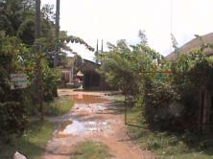 | 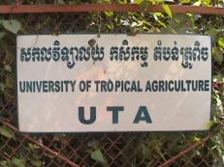
 | The entrance to UTA | UTA in Cambodia
 | An integrated approach to resource utilization begins efficient use of solar energy
 | 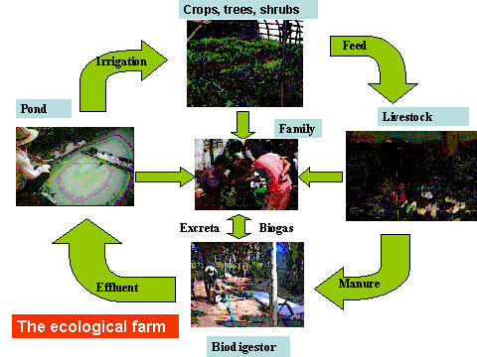
 | 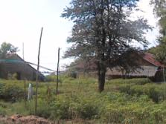 | 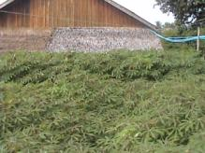
 | Cassava crop under continuous harvest | Cassava before harvesting (60 days old)
 | 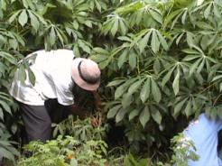 | 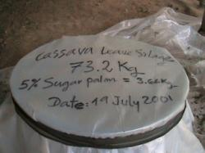
 | Harvesting cassava | Cassava leaves silage with sugar palm
 | 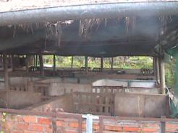 | 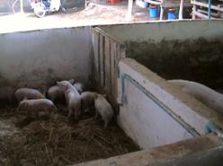
 | Pig pen | Pen for lactating sows
 | 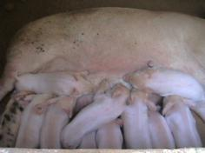 | 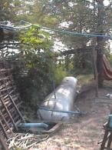
 | Forrowed sow | Plastic biodigester connected to one  of the pig pens
 | 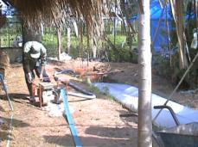 | 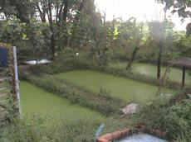
 | Effluent from the plastic biodigester is pump every day to the forage crops and aquatic plats | Duckweed ponds fertilized with effluent
 | 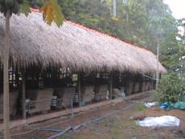 | 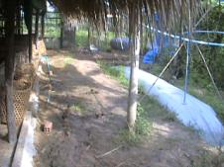
 | Cattle experimental pen | Biodigester connected to the cattle pen
 | 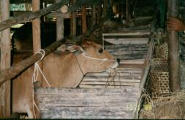 | 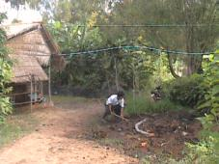
 | Use of rice straw as basal diet | Residue from the cattle feed (mainly rice straw) being moved to the chicken pen
 | 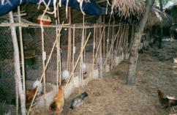 | 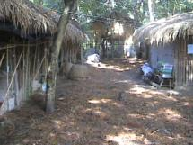
 | Chicken pen, semi-scavenging system | Use of feed residues as a way to increase the scavenging base in semi-scavenging systems
 | 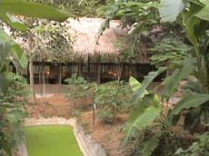 | 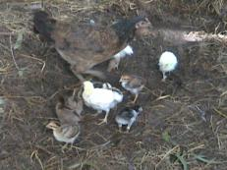
 | Duckweed ponds inside the chicken pen | Local hen raising its own chicks and added exotic chickens
 | 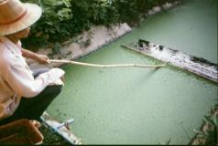 | 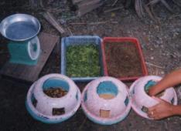
 | Harvesting duckweed | Use of duckweed as poultry feeding
 | 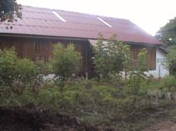 | 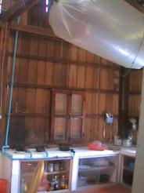
 | Students house | Use of biogas at the students house
 | 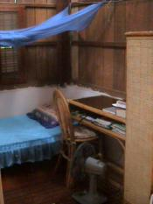 | 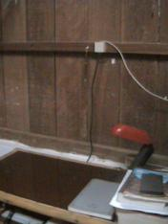
 | View of students room | Direct connection to internet in each room
 | 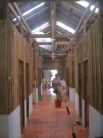 | 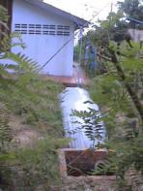
 | General view of the students house | Toilets of the students house connected to plastic biodigesters
 | 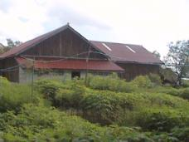 | 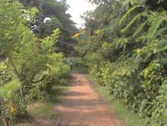
 | Lateral view of students house and crop area | Internal way in UTA
 | 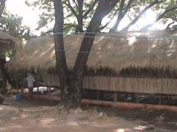 | 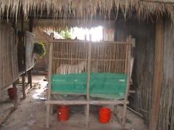
 | Experimental goat pen | Digestibility cages for goats
 | 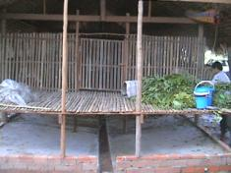 | 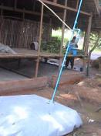
 | Floor of goat pen | Goat pen connected to the plastic biodigester as a way to recycle goat urinee. Faeces used for earthworm production
 | 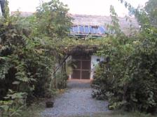 | 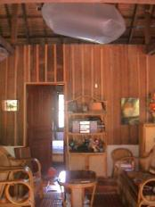
 | Thomas P, Lylian R and Sofia P house and use of solar panels | Use of biogas: reservoir bag
 | 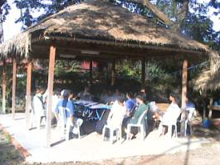 | 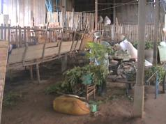
 | Multipurpose kiosk: for meetings and garage | Commercial goat pen, made with recycle wood: 60 animals
 | 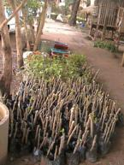 | 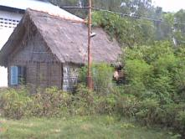
 | Trees nursery | Facilitators house
 | 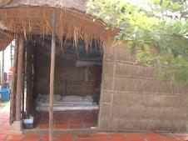 | 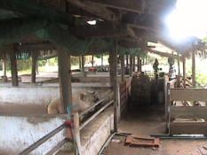
 | Biogas materials shop | Pig pen
 | Corral de cerdos | Corral de cerdos
 | 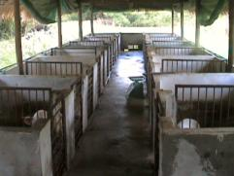 | 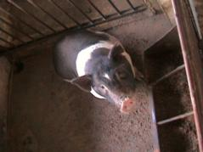
 | Experimental pig pem | Local breed from Vietnam: Mongcai
 | 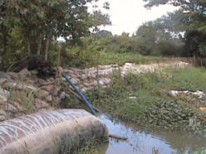 | 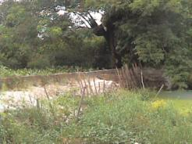
 | Biodigester connected to the pig pen )picture taken during the rainy season | Dike built during 2001 to avoid the flood
 | 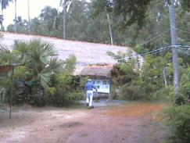 | 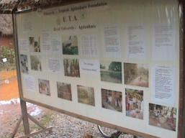
 | General view of the office, classroom and laboratory | UTA poster
 | 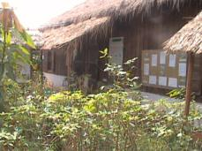 | 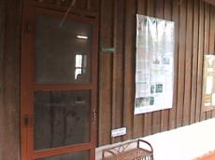
 | Office and classroom | Entrance to the classroom
 | 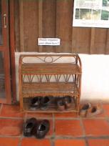 | 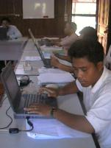
 | Asian costume: leave the shoes outside the classroom | Class room
 | 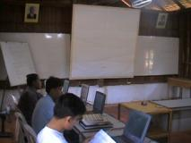 | 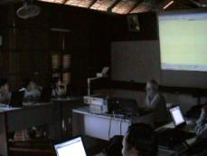
 | Each MSc student get a portable computer | Use of the LCD projector for teaching
 | 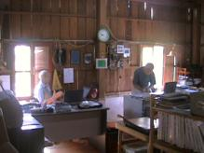 | 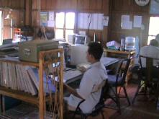
 | Office, TR Preston, Director and Julio Ly, visiting scientist | Sam Kol, Researcher
 | 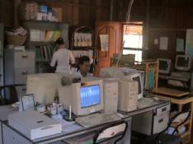 | 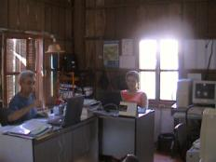
 | Computers and library | Julio Ly and Lylian Rodriguez, Coordinator
 | 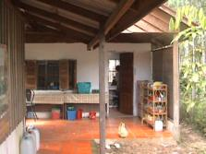 | 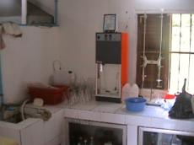
 | Laboratory | Internal view of the laboratory
 | 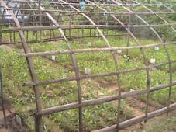 | 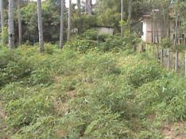
 | Experimental areas | Crop area
 | 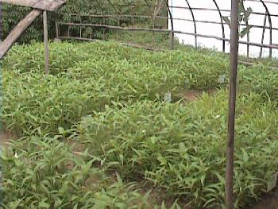 | 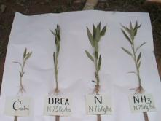
 | Experiment in the use of different levels of Nitrogen Sources for water spinach (ipomea aquatica) fertilization | C=control, Urea, N= N from effluent from plastic biodigester and NH3= calculation based on the NH3 content in the effluent
 | 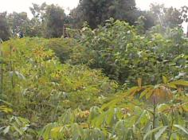 | 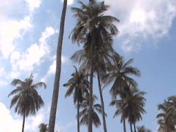
 | Cassava and mulberry | UTA is located in " Chamcar Daugn" and its meaning is coconut plantation
 | 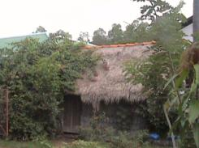 | 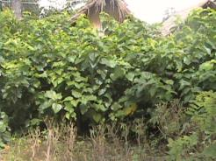
 | Housing for UTA people: students, researchers and staff | Mulberry

 |  | UTA staff in Cambodia
 | 1 | Dr Thomas R Preston, PhD | Director
 | 2 | Ms Lylian Rodríguez, MSc | International Coordinator/IFS Research Grant/PhD Student
 | 3 | Mr Khieu Borin, MSc | National Coordinator/IFS Research Grant /MEKARN PhD Student
 | 4 | Dr Julio Ly, PhD | Head of Laboratory
 | 5 | Mr Chiev Phiny | Manager and Researcher
 | 6 | Mr Pok Samkol | Laboratory Assistant and researcher
 | 7 | Ms Poev Vanmolika | Administrative Assistant
 | 8 | Mr Hieng Vuth | Manager assistant
 | 9 | Mr Chea Kimly (Pout) | Field Assistant
 | 10 | Ms Prouch Yet | Field Assistant
 | 11 | Ms Thoeun Sokroeun | Field assistant
 | 12 | Mr Phin Pheoun | Field Assistant
 | 13 | Ms Chhieng Maly | Cleaner

 |  | UTA Students/researchers 2002
 | 1 | Mr Siv Kong | Undergraduate Student | Animal Production / RUA - BSc Thesis
 | 2 | Mr Chan Noeng | Undergraduate Student | Agronomy/RUA/ BSc Thesis
 | 3 | Mr Sam Sok Chea | Undergraduate Student | Animal Production / RUA
 | 4 | Mr Try Van Vuth | Undergraduate Student | Fishery / RUA
 | 5 | Mr Keo Sath | Undergraduate Student | Animal Production / RUA
 | 6 | Mr Tong Sokhom | Undergraduate Student | Agronomy/RUA
 | 7 | Mr Hang Vong | Undergraduate Student | Rural Develpoment / Maharishi Vedic University
 | 8 | Mr Hean Pheap | Undergraduate Student | Rural Development / Maharishi Vedic University
 | 9 | Mr Kong Ponlok | Undergraduate Student | Agronomy / Maharishi Vedic University
 | 10 | Mr No HemChan Monor | Undergraduate Student | Agronomy / Maharishi Vedic University
 | 11 | Mr Hong Bonna | Undergraduate Student | Agronomy / Maharishi Vedic University
 | 12 | Mr Men Sok Meng | Undergraduate Student | Rural Development / Maharishi Vedic University
 | 13 | Mr Ki Ouern | Undergraduate Student | Rural Development / Maharishi Vedic University
 | 14 | Mr Nhem ChanThol | Undergraduate Student | Agronomy / Maharishi Vedic University
 | 15 | Mr Min Sophanith | Undergraduate Student | Agronomy / Maharishi Vedic University
 | 16 | Mr So Ram | Undergraduate Student | Animal Production / Preakliep
 | 17 | Mr Khem Ponlok | Undergraduate Student | Animal Production / Preakliep
 | 18 | Mr Srey Sam Ann | BSc Thesis Student 2001 | Fishery/RUA
 | 19 | Mr Chea Simeth | BSc Thesis Student 2001 | Animal Production / RUA
 | 20 | Mr Mith Sok Pao | BSc Thesis Student 2001 | Animal Production / RUA
 | 21 | Mr Chiev Phiny | UTA - MEKARN Researcher | UTA Foundation
 | 22 | Mr Pok Samkol | UTA - MEKARN Researcher | UTA Foundation
 | 23 | Mr Heng Savoeurn | MSc thesis | MSc student -Royal Academy of Cambodia
 | 24 | Mr Pen Rotha | UTA MSc student | SCALE
 | 25 | Mr Kean Sophea | UTA MSc student | UNDP Service Centre
 | 26 | Mr Bun Tean | UTA MSc student | Royal University of Agriculture - RUA
 | 27 | Mr Pech Sovanno | UTA MSc student | CHUP Rubber &
 | 28 | Mr Meas Meanith | UTA MSc student | CHUP Rubber &
 | 29 | Mr Sath Sonetra | UTA MSc student | CHUP Rubber &
 | 30 | Mr Him Aun | UTA MSc student | CHUP Rubber &
 | 31 | Mr Sokphoun Sopheak | UTA MSc student | Royal University of Agriculture / RUA
 | 32 | Mr Nop Phary | UTA MSc student | Ministry of Environment
 | 33 | Mr Pich Sophin | UTA MSc student | School of Agriculture Prek Leap
 | 34 | Mr Mom Sophal | UTA MSc student | Ministry of Agriculture Forestry and Fisheries
 | 35 | Mr Chhay Ty | MEKARN MSc Student | UTA Foundation
 | 36 | Ms Seng Sokerya | MEKARN MSc Student | UTA Foundation
 | 37 | Mr San Thy | MEKARN MSc Student | UTA Foundation
 | 38 | Mr Prak Kea | MEKARN MSc Student | RUA
 | 39 | Mr Theng Kouch | MEKARN MSc Student | RUA
 | 40 | Mr Hong Samnang | IFS Research Grant | UTA Foundation
 | 41 | Mr Khieu Borin, MSc | MEKARN PhD Student and IFS Research Grant | UTA Foundation
 | 42 | Ms Lylian Rodríguez J | IFS Research Grant
 |  |  | Total = 42 students

Page prepared by Lylian Rodríguez J lylianr@utafoundation.org and
T R Preston regpreston@utafoundation.org
Pictures by Lylian Rodríguez J
Last update 3rd June 2002

